Art: Constable and Turner

Next week, we will be exploring art that depicts weather.
I would like you to research into the following famous artists:

John Constable

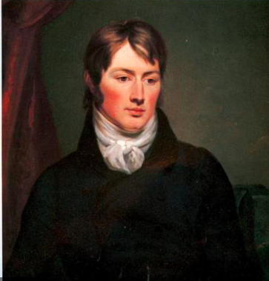

Joseph Mallord William Turner

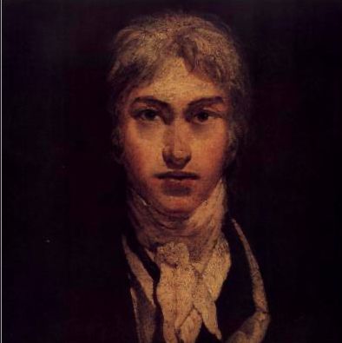

Think about the following questions when researching:

- When were they born and where?
- What type of art do they produce?
- What is their most famous piece of art?
- What is their style of art?

You can even create a piece of art influenced by these artists.
If you do create any artwork at home. You can take a photo of the finished product, upload the photo to your device and then insert it into this Google document.
Please send a comment if you need any further advice or help.

This art homework needs to be turned in on Monday 23rd November.
Ms Kangal-Nurse 16.11.2020

