The Myth of Pandora’s Box

Are you nosy? Do you like secrets? Have you ever done something that you’ve been warned not to, just to find out a secret? All through time there have been stories about people being told not to open doors, cupboards, gates and all sorts of other things, and in many of the stories the people just didn’t listen. One person who did not listen is Pandora. Her story is from Ancient Greece, where her nosiness changed the world forever!

Not hundreds but thousands of years ago, in ancient Greece, there lived two brothers called Epimetheus and Prometheus. Although they lived in a world where the gods were in charge, they liked nothing more than to annoy the gods. One day, Zeus, a particularly powerful god, decided to teach them a lesson.

Zeus ordered the gods to create a beautiful woman. Her name was Pandora and she was to marry Epimetheus. As a wedding present, Zeus gave Pandora a beautiful box but there was one special condition, she was never to open it!

All day Pandora’s husband Epimetheus was out working. All day all she could think about was what was in the box. Pandora could not understand why Zeus would give her a box that she could not open. It made no sense to her. Pandora was bored and lonely and her curiosity became unbearable.

PAUSE = Complete activity 1 for Tuesday. Continue reading.

One day, when she was sure that Epimetheus was out annoying the gods, Pandora searched for the key to open the box. “I know it’s here somewhere,” she muttered to herself as she opened cupboards and drawers. There it was, high on a shelf in their bedroom! With shaking hands, Pandora slid the key into the lock and turned it.

PAUSE = Complete activity for 2 for Tuesday. Continue reading tomorrow.

She took a deep breath, closed her eyes and slowly, with trembling hands, opened the lid of the box, imagining what could be inside: rubies as red as the blazing sunset, jewel encrusted gowns, piles of gold coins. But there were no coins or jewellery, no gowns or gems, for all at once every evil and spite, every sadness and misery flew out. Like a swarm of insects, they fled the house and infested the earth with heartache and sorrow.

Pandora slammed the lid shut and turned the key. “What have I done?” she sobbed, holding her head in her hands. Sometime later, Pandora noticed a fluttering sound coming from the box, as if something was trapped inside. Terrified, she pressed her ear to the box. “Let me out,” a small voice pleaded gently, “I mean you no harm.”

Once again, with shaking hands, Pandora unlocked the box and opened the lid. A beautiful butterfly of hope fluttered out of the box, for although Pandora had released pain and suffering into the world, she had also allowed hope to follow them.

Tuesday 1
What do you think the box looked like? Can you draw a picture with labels?

Tuesday 2
What do you think could be inside the box? Can you tell me your ideas in just 3 sentences? You may add pictures once finished.

Wednesday

You’ve completed the story! Did you enjoy it?
I would now like you to write out the answers to the questions below in full sentences. Don’t forget to read the story again to help you!

- Who was Prometheus?

- Where is the story set?

- Why do you think hope is a butterfly in the story?

- What is the evil that comes out of the box compared to?

Thursday

Apollo was the Greek god of knowledge. He has found these words in the story and wants to know if you can help sort them out. Firstly, can you put them into alphabetical order?

powerful condition curiosity unbearable trembling rubies gown spite fled infested sobbed pleaded released hope

Now match the word to its meaning in the story – the first one has been done for you.

Powerful Shaking slightly

Condition Dress

Curiosity Something that must happen

Unbearable Set free

Trembling Cruelty/upsetting

Rubies Strong and confident

Gown Cried

Spite To ask or beg

Fled Unpleasant

Sobbed Escaped from something/someone

Pleaded A feeling that things will go well

Released Wanting to know about something

Hope Red precious stones

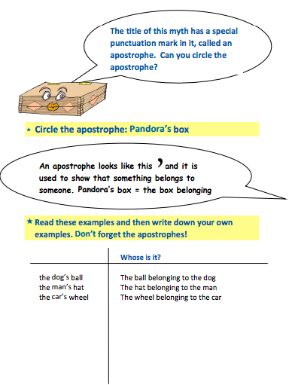
Friday

