Hello Year 6!
Each week I will be posting your homework here. You will have reading, maths, spellings and our Word of the Week to look at.
- Try and read every day for at least 20 minutes – this may just be looking at one page and discussing what you can say and why things are happening in the story. Reading isn’t just about reading the words on the page, it’s all about understanding what the story is trying to tell us. We will be looking at reading fluency so please make sure you
- You will have maths activities to have a go at, these are called fluency activities. You need to keep practising these skills so you become really accurate and quick! Try and practise these skills for 10 minutes per day.
- You will get five words to look at and learn every week, these will help with your reading and writing in class.
Homework week beginning 5th October 2020
Reading | Word of the Week | Spelling | Maths
Make sure you are continuing to read for at least 20 minutes every day at home on MyOn or your Accelerated Reader. Try to work on your reading pace this week. | This is our Word of the Week – find out what it means.  Acrid  Can you use it in a sentence?  Can you modify it? | Can you learn to read and write these five spellings:  Accommodate  Especially  Variety  Recommend  Profession | We are looking at multiplication this week.  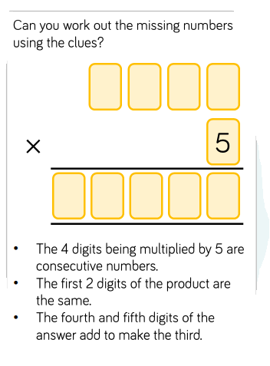
Other: Topic research/project ….Design a prayer leaflet for the Rosary

