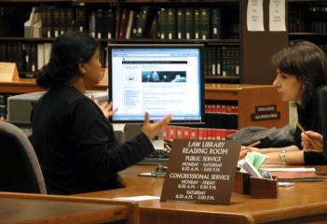

There are other ‘**librarians’** including Yahoo, Bing etc

We can think of the **Internet network** like a library building – it is the structure that holds all the information on the web…

The **World Wide Web** is a bit like all the books inside the library…

…and the **Google** **Search Engine** is like a Librarian who looks around the library at all the books and finds one you need…

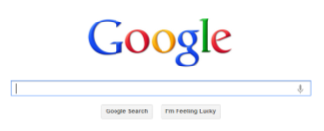

A **website** is like an information book on a particular subject…

A individual **web page** is like a page inside an information book…