Maths | Reading | Spelling | Word of the week
Please refer to your maths fluency book for this weeks homework task.  Your maths fluency book needs to be signed by an adult at home every evening.  You do not need to complete the task in the fluency book. It is for an adult to sign/make comments. | Please remember that your book and reading record need to be brought into school every day.  Your reading record needs to be signed every evening and an adult at home should sign ‘finished’ when the book is complete. You cannot complete a follow up task or quiz until this has been done.  You should be reading for 20+ minutes each day. | Can you learn to read and write:  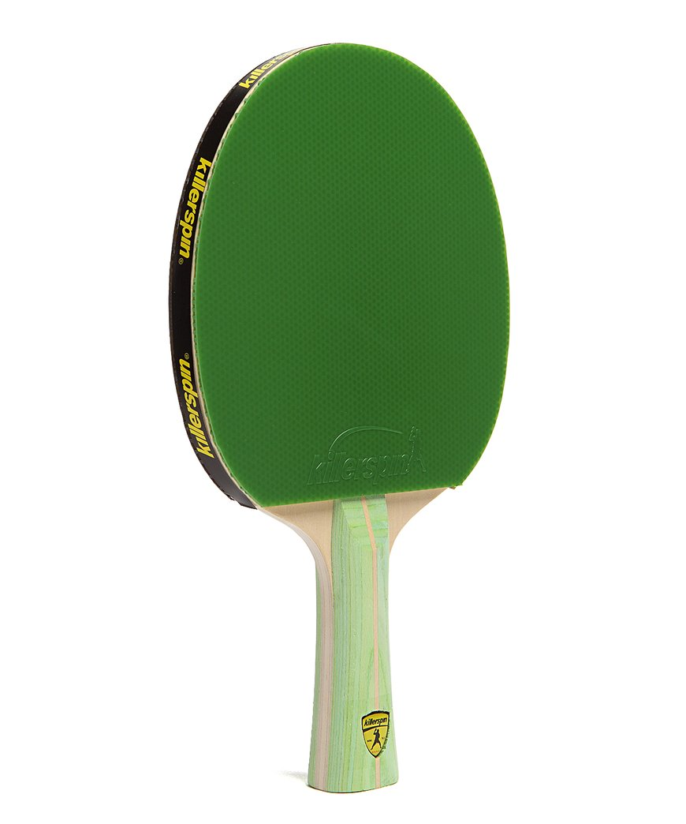  PING:  door  floor  poor  find  kind  PONG:  neighbour  weight  sleigh  eighteen  freight  Your spelling group has been stuck into the back of your reading record. Please make sure you are learning the correct spellings. | Our word of the week is…  Can you find out what it means? Are there any synonyms (related words)? Can you use it in a sentence?

